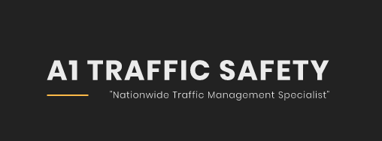

Cotton Court Business Centre
Church Street
Preston
Lancashire
PR1 3BY

Protection of the Public

A1 Traffic Safety have designed and implemented quality procedures, inline with applicable British Standards to ensure we conduct a professional service, while ensuring members of the public are also protected and not put at risk following our activities. This also includes employees, customers, consumers, and other workers who may be affected by any of the services carried out by A1 Traffic Safety.

The following activities are carried out to identify any potential danger that our services may bring to the public:

•Pre quotation survey (to understand customer requirements and how this may affect the public e.g. unique customer requirements that may involve interaction with the public e.g. events).
•Site survey (the information is used to understand our customer requirements further and how this may affect the public e.g. entrance and exit points).
•Risk assessments (the likihood of a risk occuring and how could this risk affect the public).
•Emergency procedures (emergency procedures will take into consideration potential affects on the public e.g. bomb threat)

We shall monitor public perception of our services by:

•Engaging with the public through social media.
•Compliments.
•Complaints.
•Positive and negative press.
•Incidents / accidents involving the public

All feedback is welcomely accepted and will be reviewed with the aim of continually improving our relationship and protection of the public.

If you would like to leave any feedback,
please send an email to info@a1ts.co

https://www.gov.uk/terrorism-national-emergency

